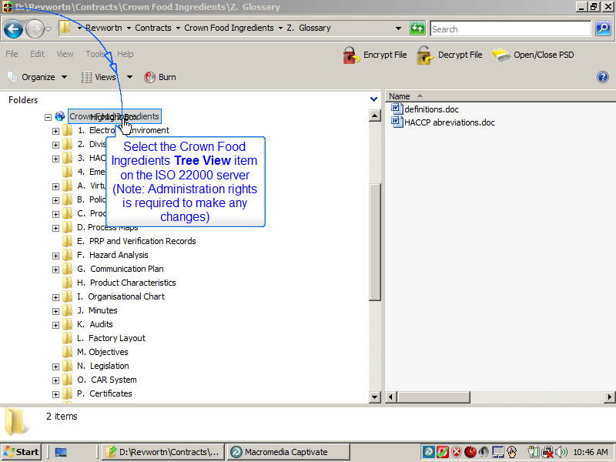
Slide 1
Note:
Select the Crown Food Ingredients Tree View item on the ISO 22000 server
(Note: Administration rights is required to make any changes)
Notes:

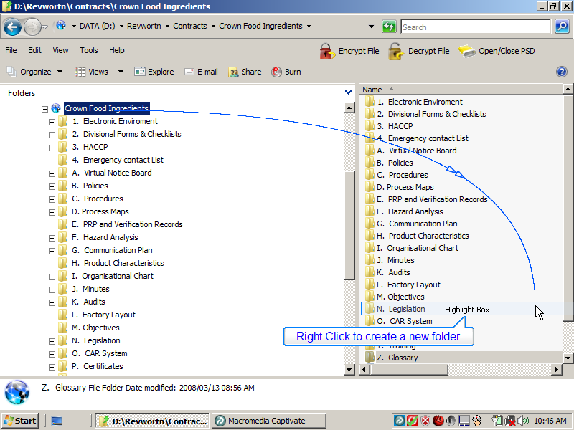
Slide 2
Note:
Right Click to create a new folder
Notes:

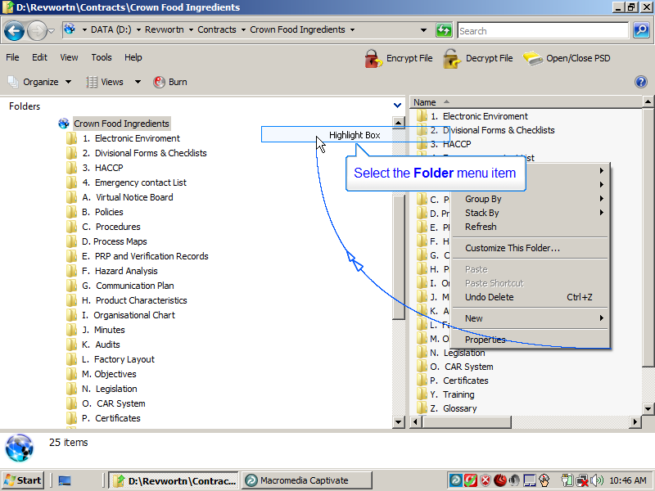
Slide 3
Note:
Select the Folder menu item
Notes:

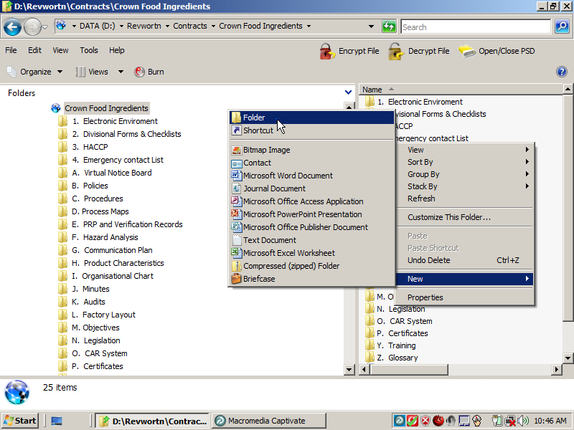
Slide 4
Note:
Notes:

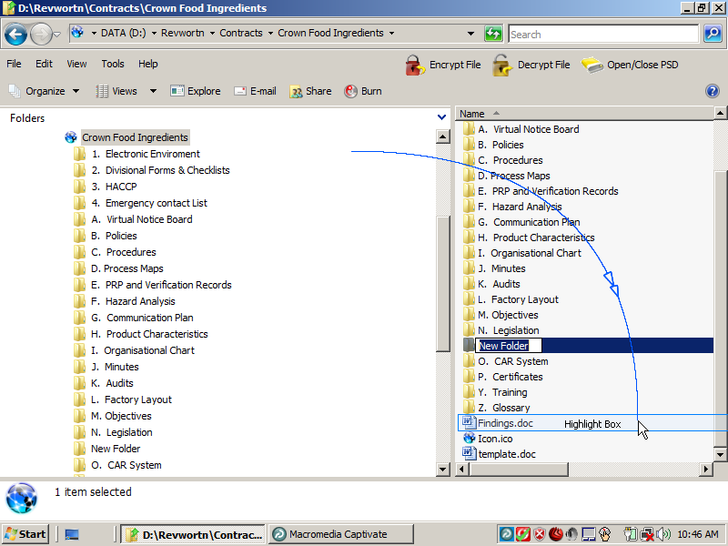
Slide 5
Note:
Notes:

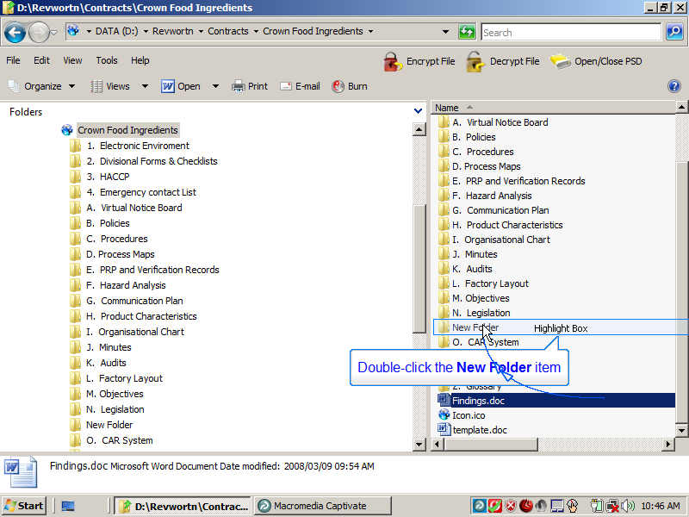
Slide 6
Note:
Double-click the New Folder item
Notes:

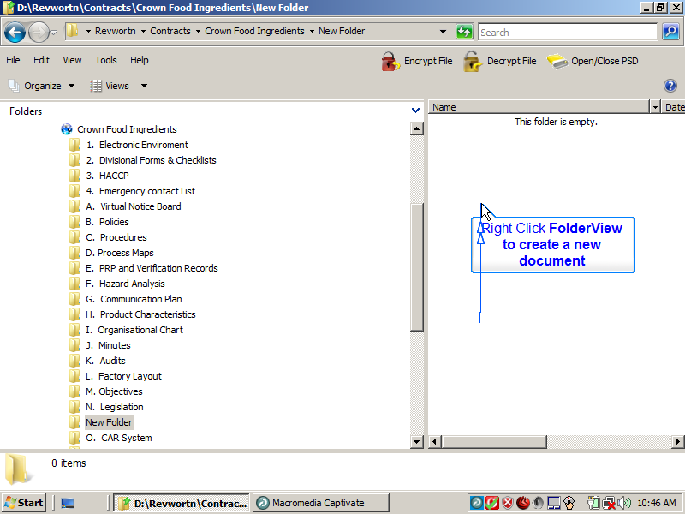
Slide 7
Note:
Right Click FolderView to create a new document
Notes:

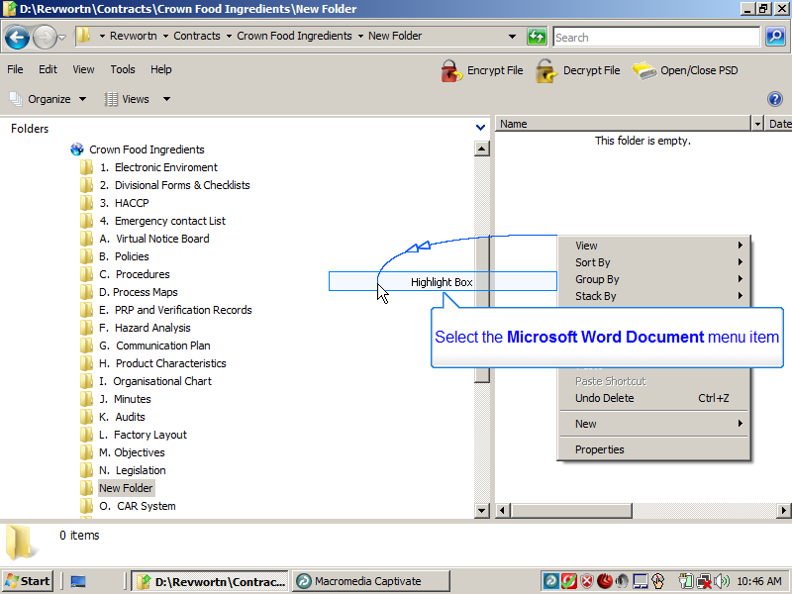
Slide 8
Note:
Select the Microsoft Word Document menu item
Notes:

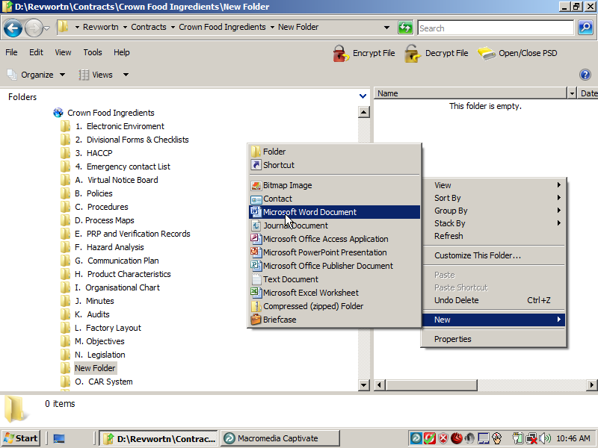
Slide 9
Note:
Notes:

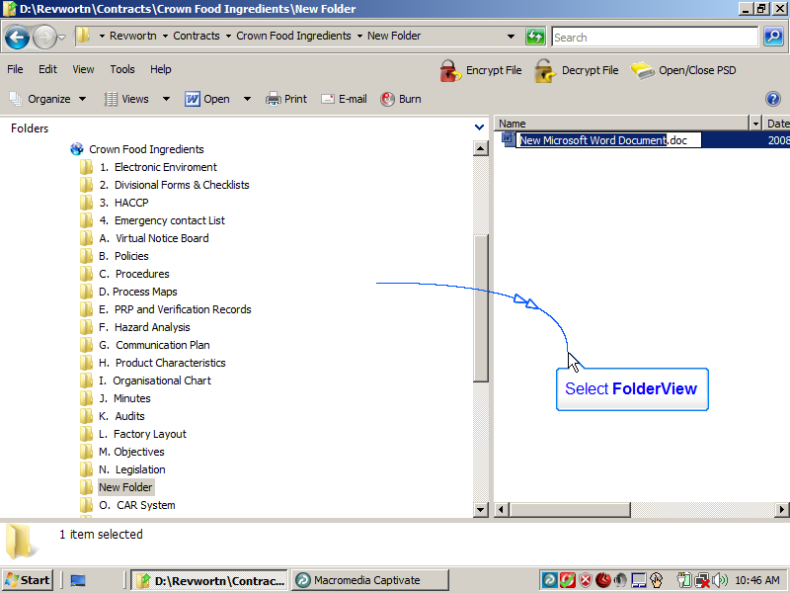
Slide 10
Note:
Select FolderView
Notes:

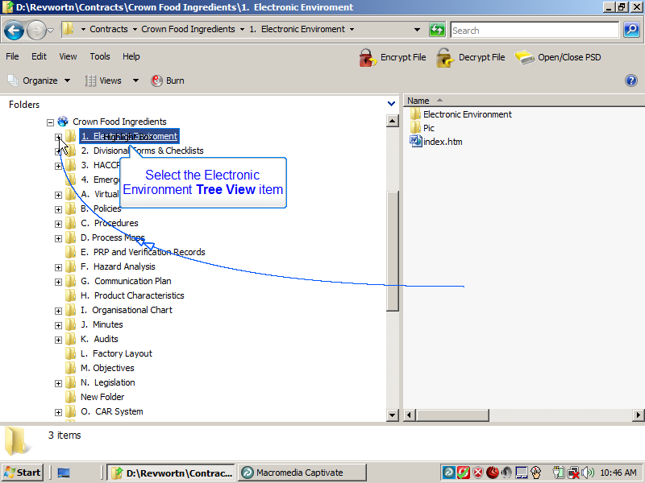
Slide 11
Note:
Select the Electronic Environment Tree View item
Notes:

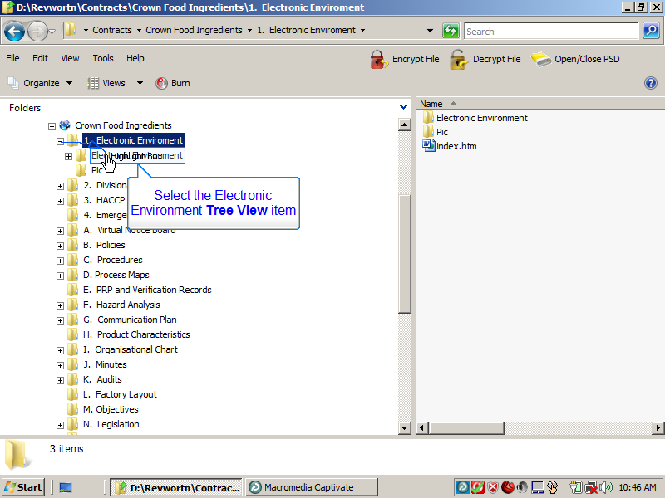
Slide 12
Note:
Select the Electronic Environment Tree View item
Notes:

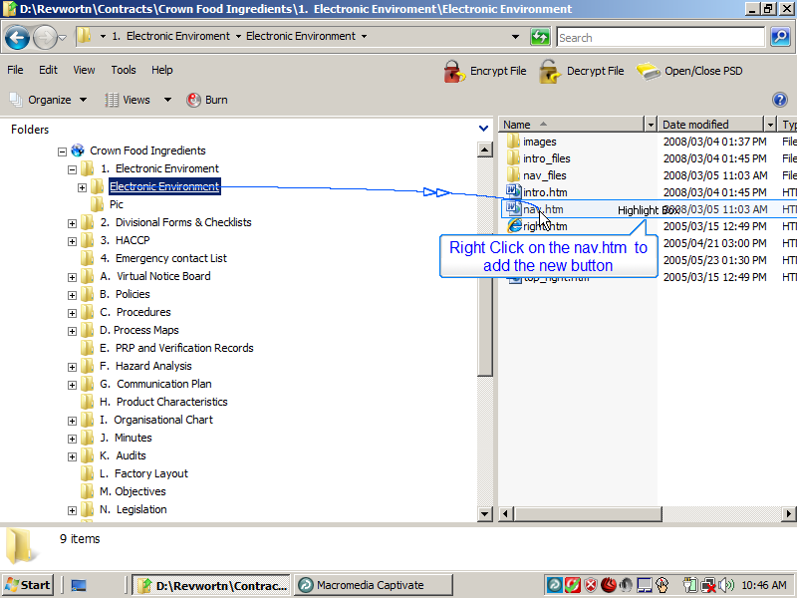
Slide 13
Note:
Right Click on the nav.htm to add the new button
Notes:

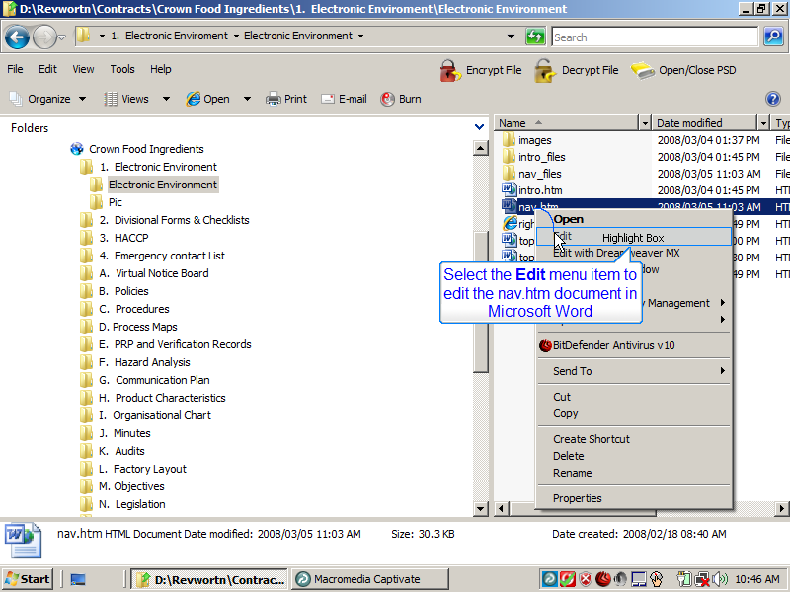
Slide 14
Note:
Select the Edit menu item to edit the nav.htm document in Microsoft Word
Notes:

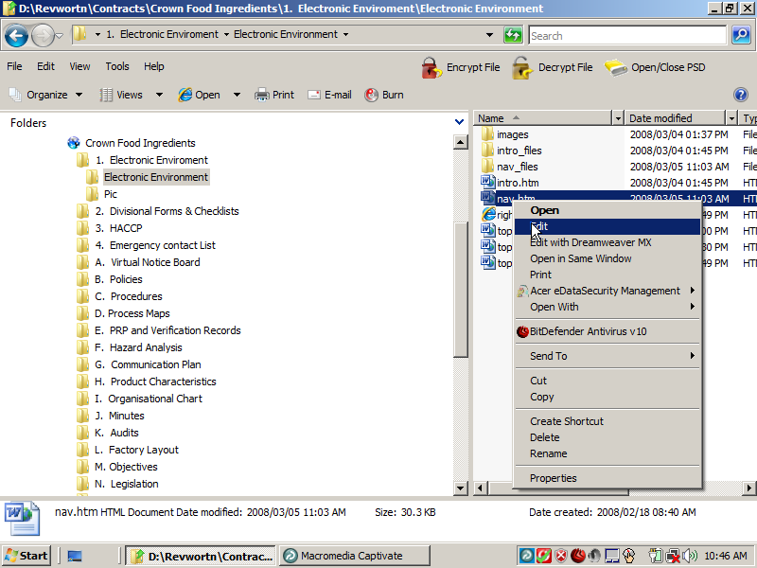
Slide 15
Note:
Notes:

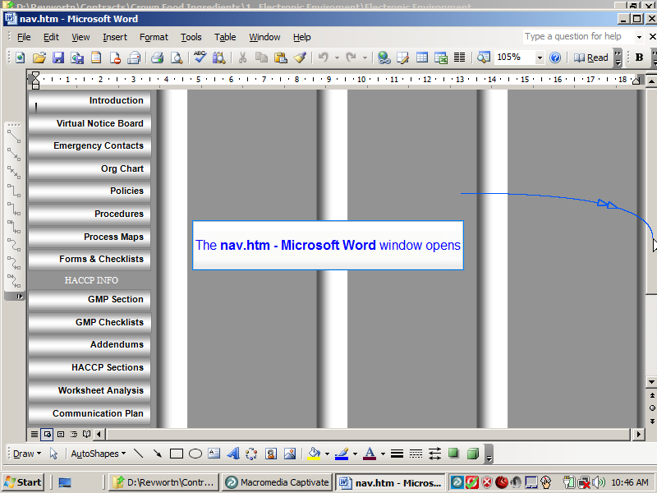
Slide 16
Note:
The nav.htm - Microsoft Word window opens
Notes:

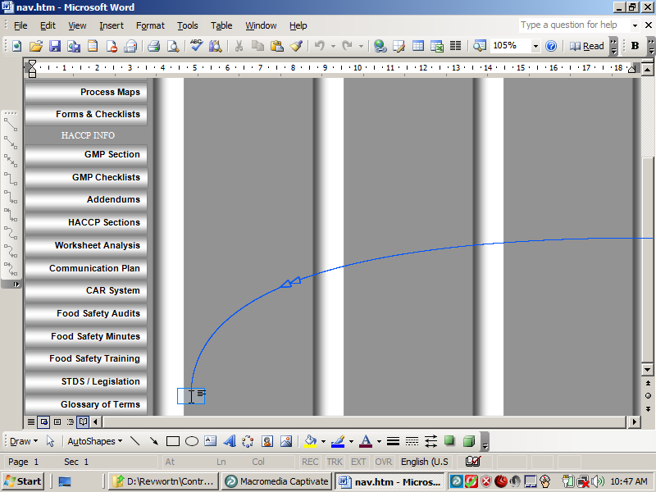
Slide 17
Note:
Notes:

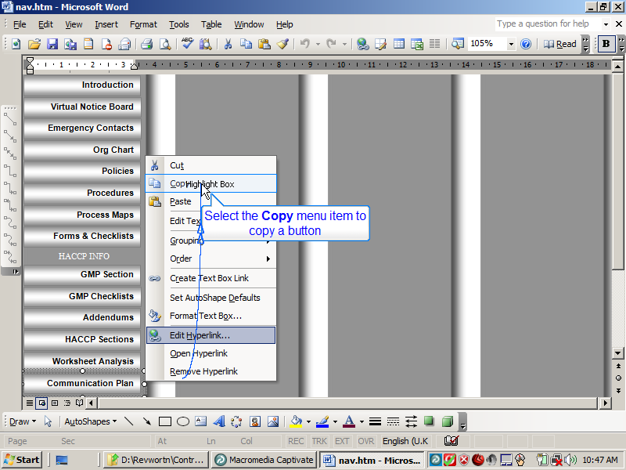
Slide 18
Note:
Select the Copy menu item to copy a button
Notes:

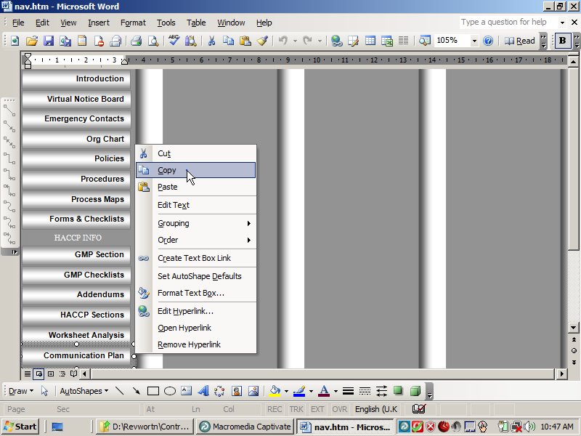
Slide 19
Note:
Notes:

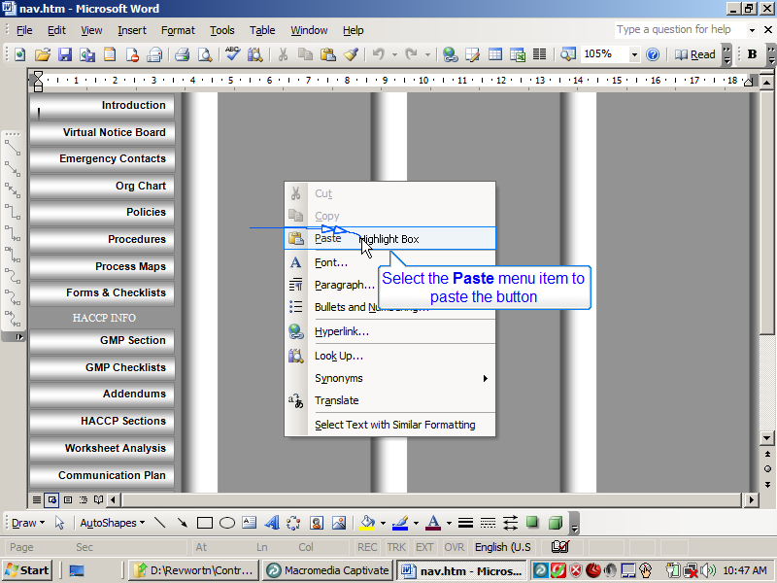
Slide 20
Note:
Select the Paste menu item to paste the button
Notes:

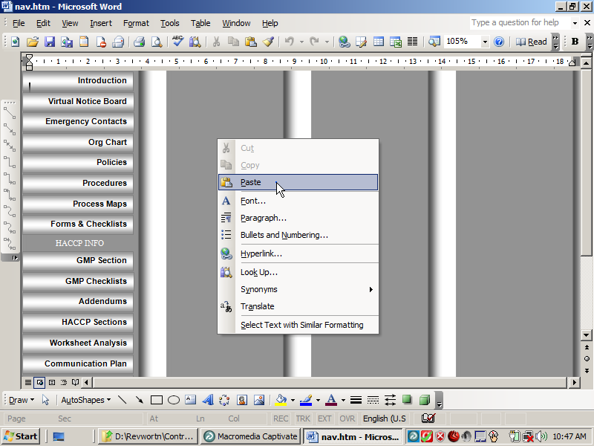
Slide 21
Note:
Notes:

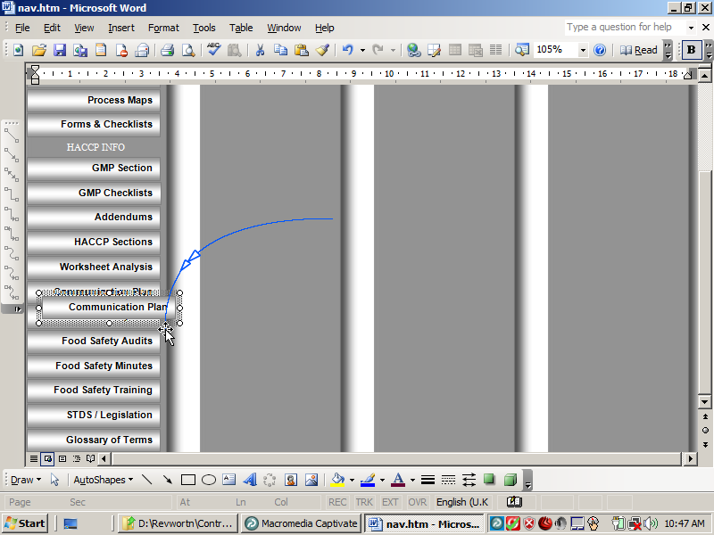
Slide 22
Note:
Notes:

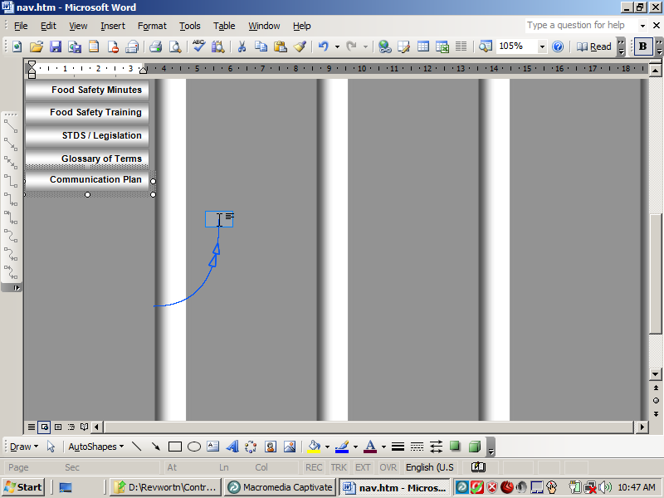
Slide 23
Note:
Notes:

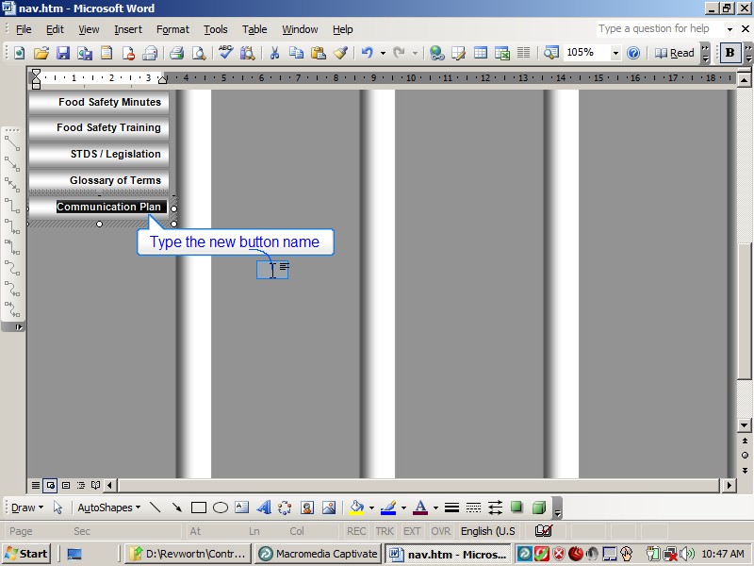
Slide 24
Note:
Type the new button name
Notes:

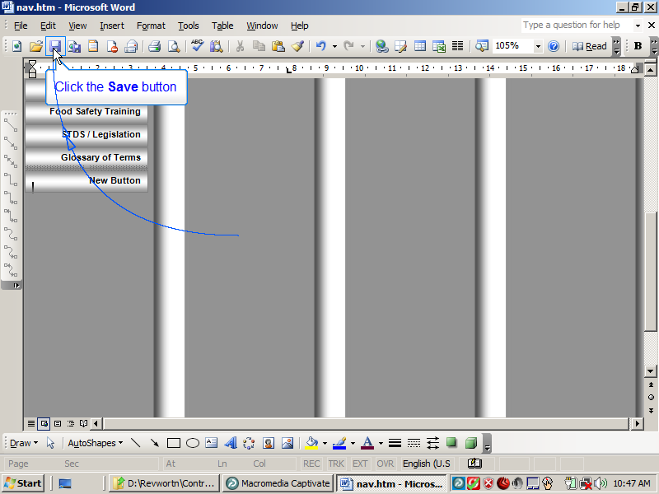
Slide 25
Note:
Click the Save button
Notes:

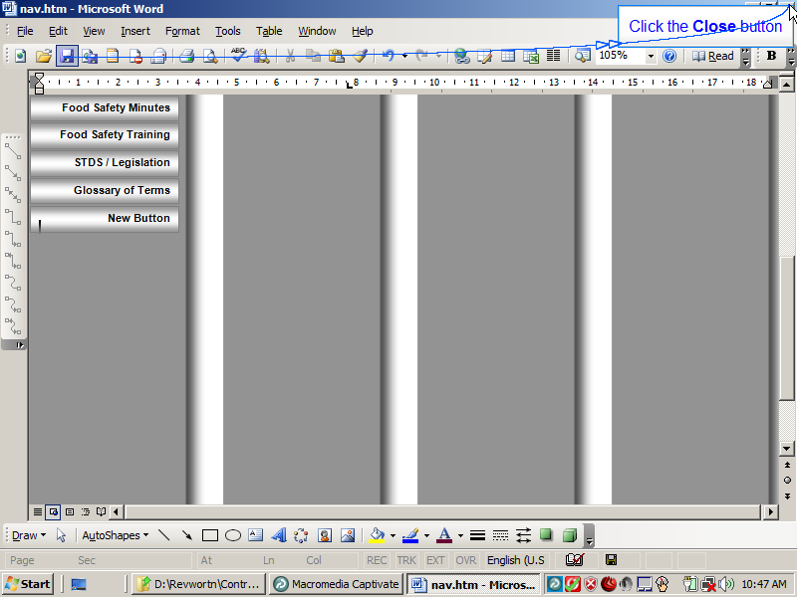
Slide 26
Note:
Click the Close button
Notes:

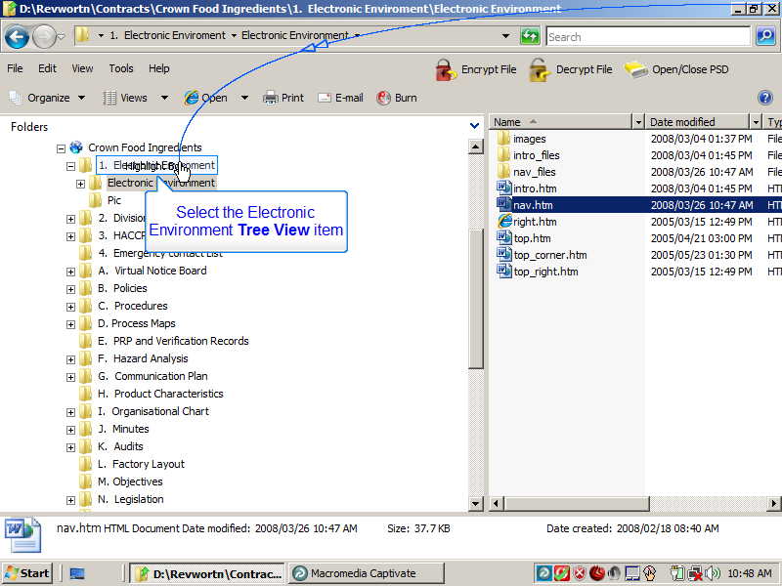
Slide 27
Note:
Select the Electronic Environment Tree View item
Notes:

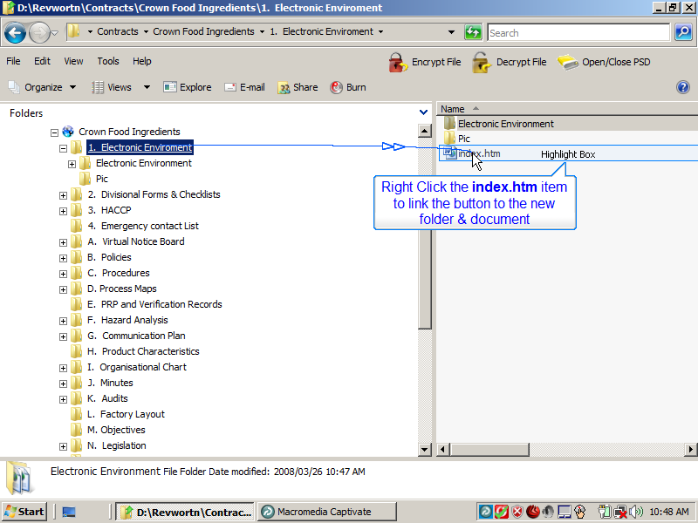
Slide 28
Note:
Right Click the index.htm item to link the button to the new folder & document
Notes:

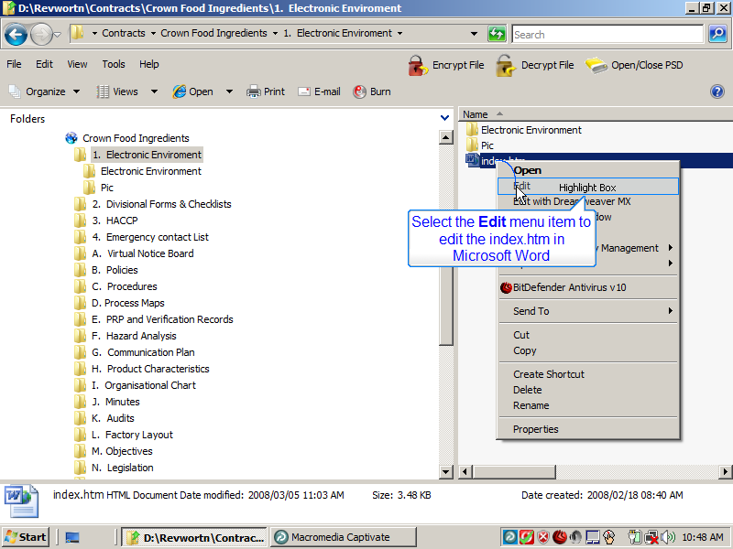
Slide 29
Note:
Select the Edit menu item to edit the index.htm in Microsoft Word
Notes:

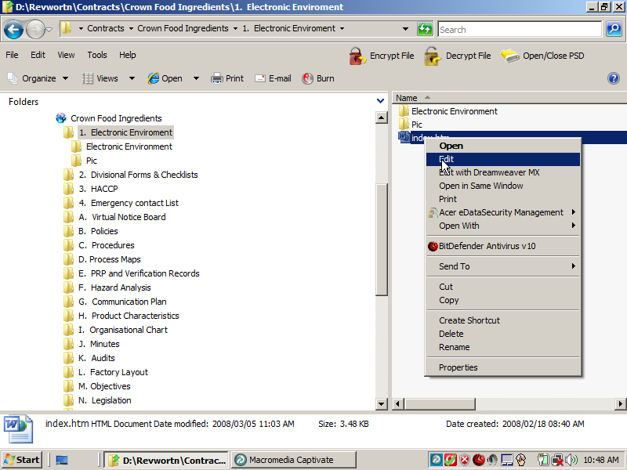
Slide 30
Note:
Notes:

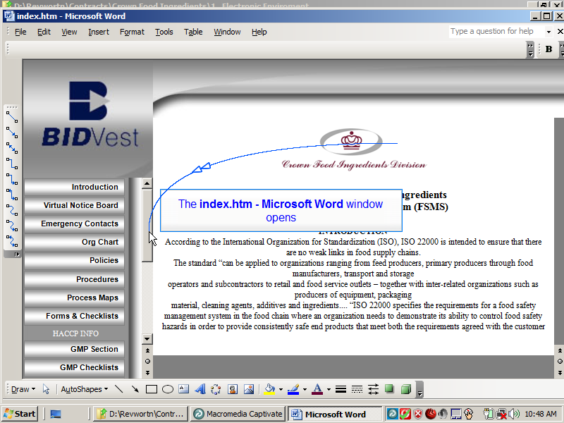
Slide 31
Note:
The index.htm - Microsoft Word window opens
Notes:

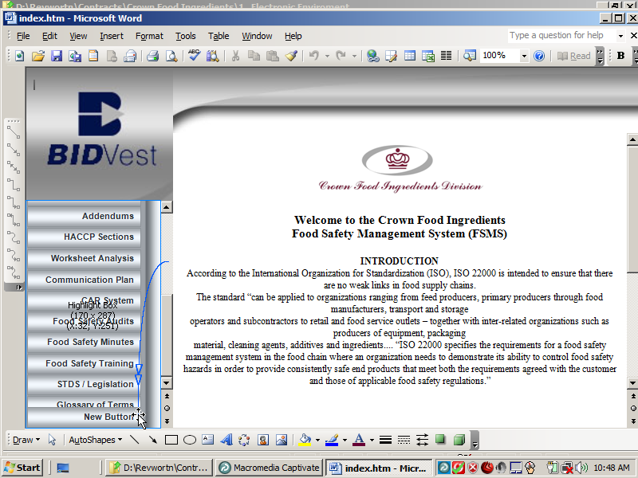
Slide 32
Note:
Notes:

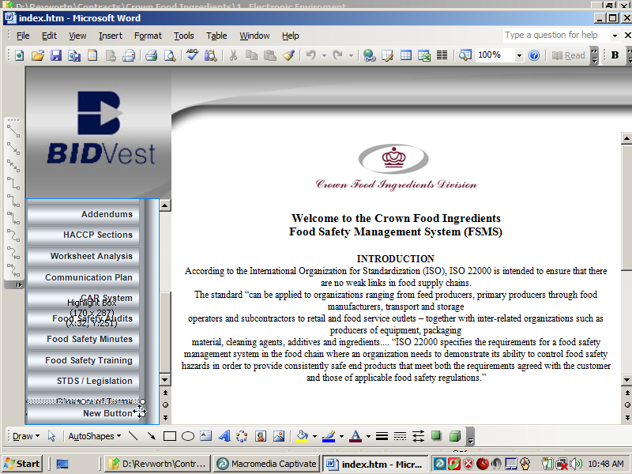
Slide 33
Note:
Notes:

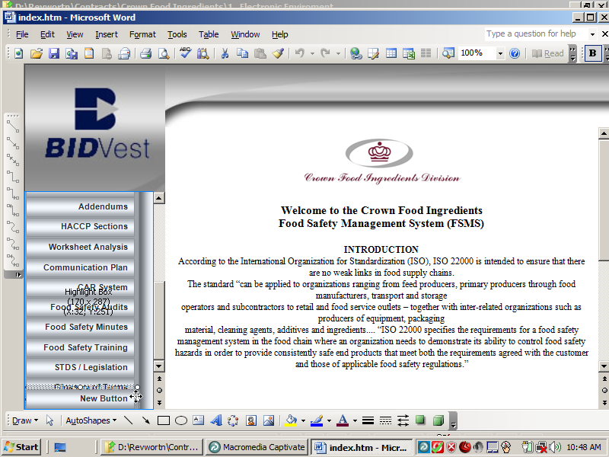
Slide 34
Note:
Notes:

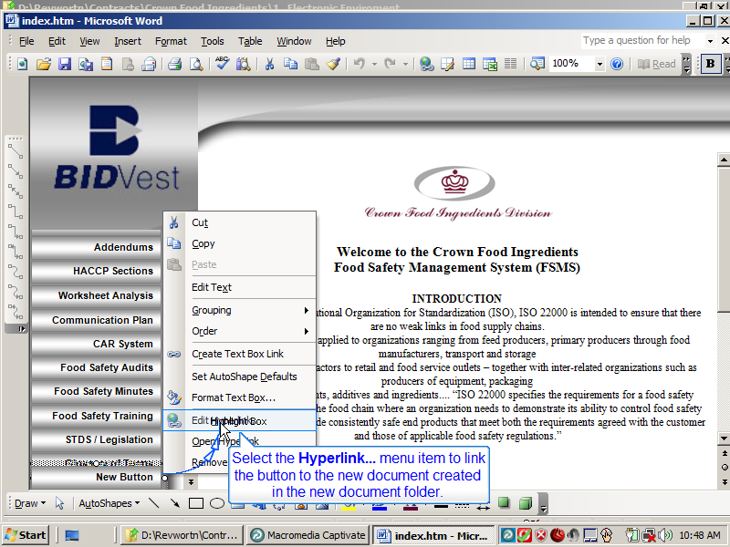
Slide 35
Note:
Select the Hyperlink... menu item to link the button to the new document created in the new document folder.
Notes:

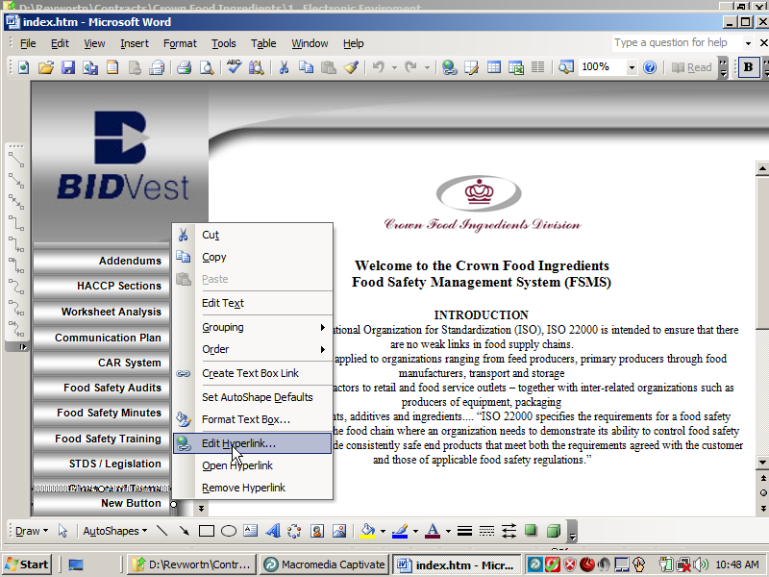
Slide 36
Note:
Notes:

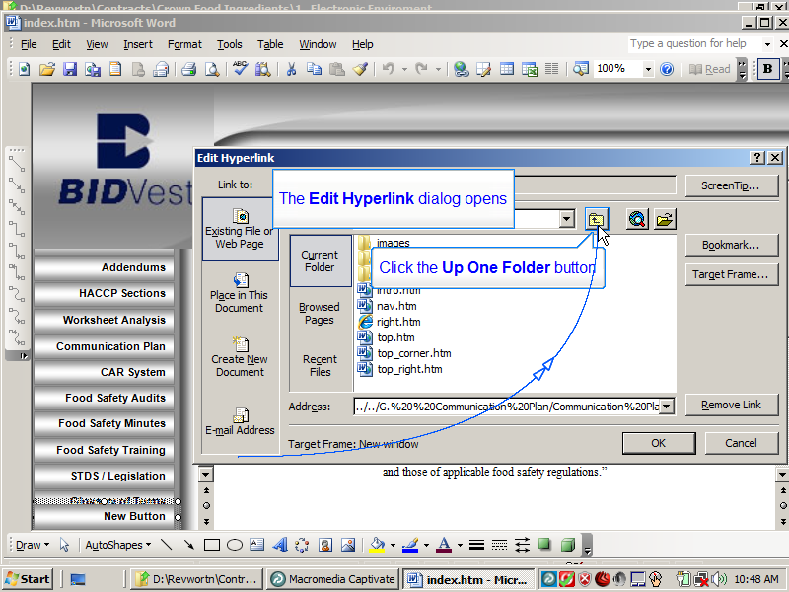
Slide 37
Note:
The Edit Hyperlink dialog opens
Click the Up One Folder button
Notes:

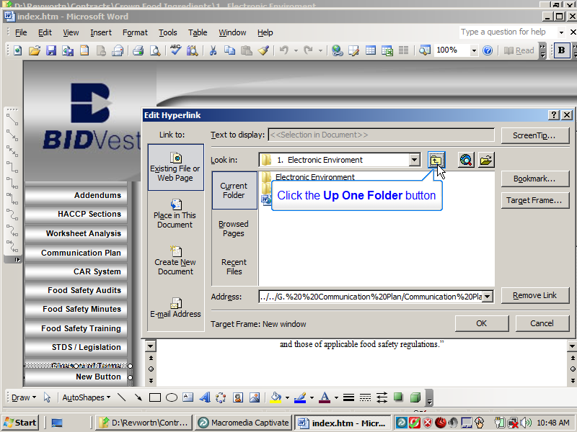
Slide 38
Note:
Click the Up One Folder button
Notes:

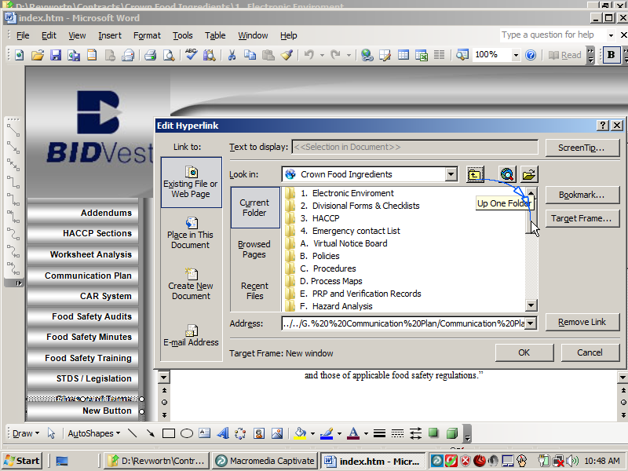
Slide 39
Note:
Notes:

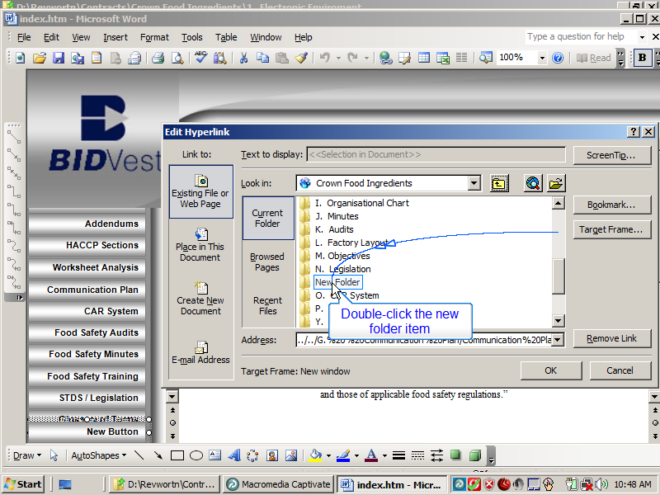
Slide 40
Note:
Double-click the new folder item
Notes:

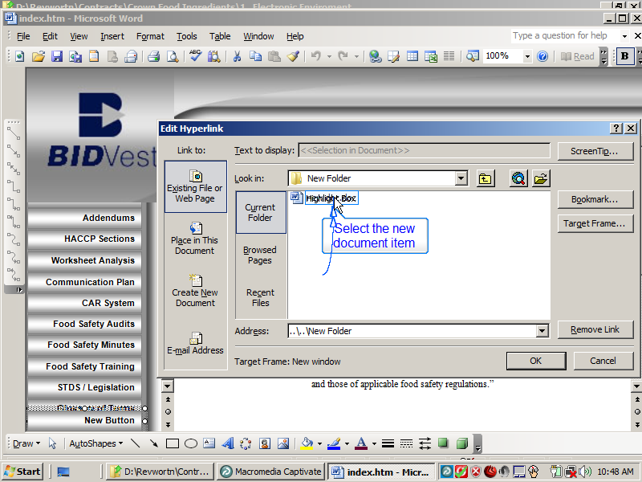
Slide 41
Note:
Select the new document item
Notes:

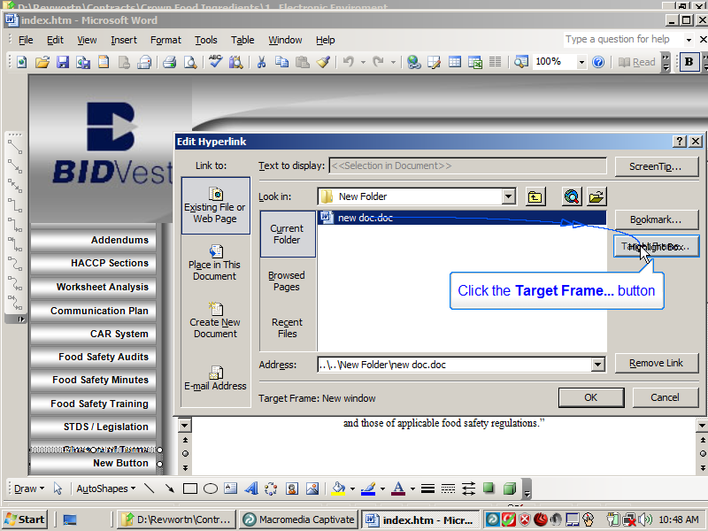
Slide 42
Note:
Click the Target Frame... button
Notes:

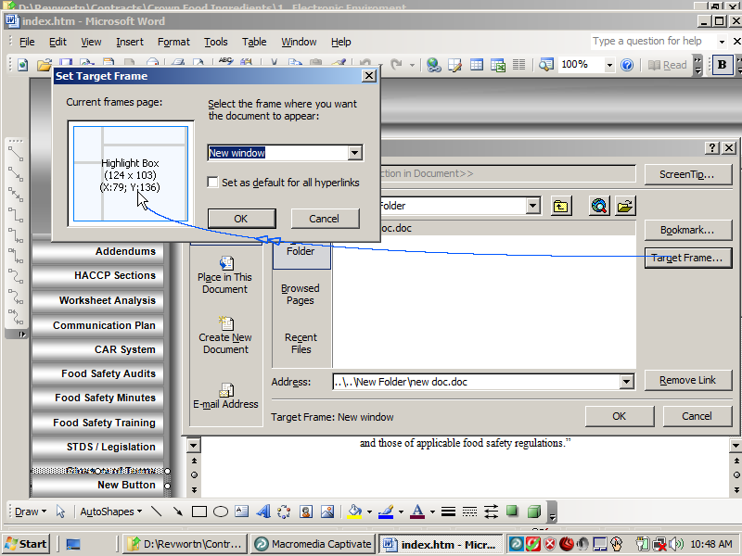
Slide 43
Note:
Notes:

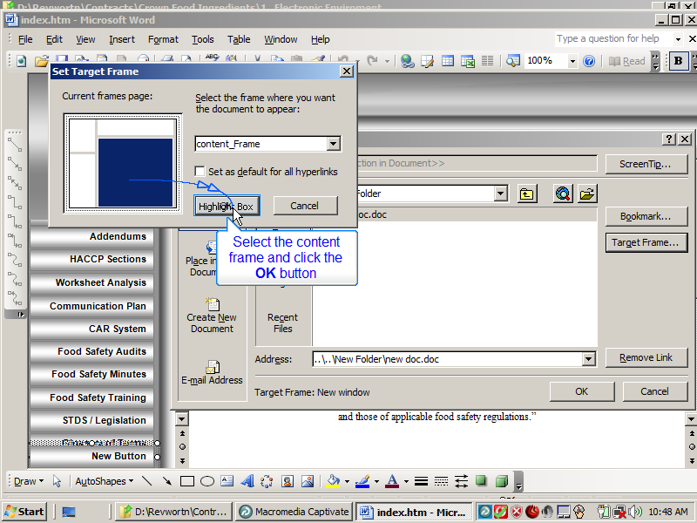
Slide 44
Note:
Select the content frame and click the OK button
Notes:

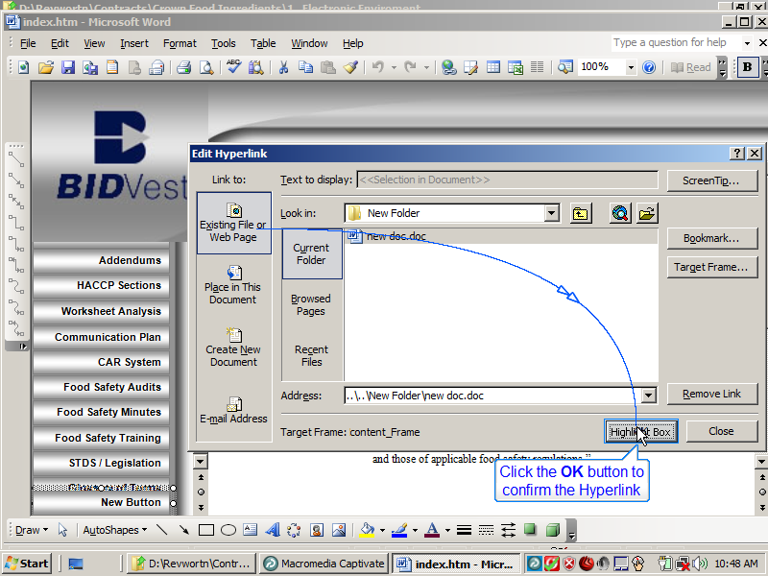
Slide 45
Note:
Click the OK button to confirm the Hyperlink
Notes:

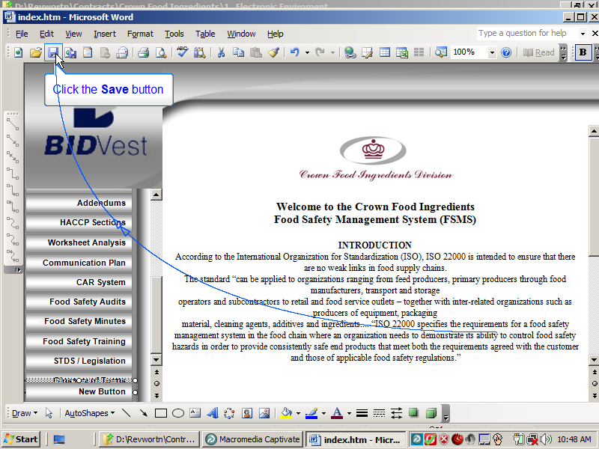
Slide 46
Note:
Click the Save button
Notes:

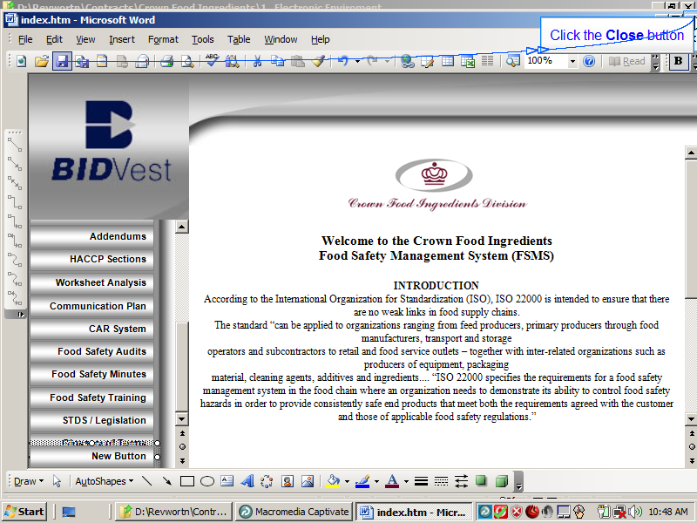
Slide 47
Note:
Click the Close button
Notes:

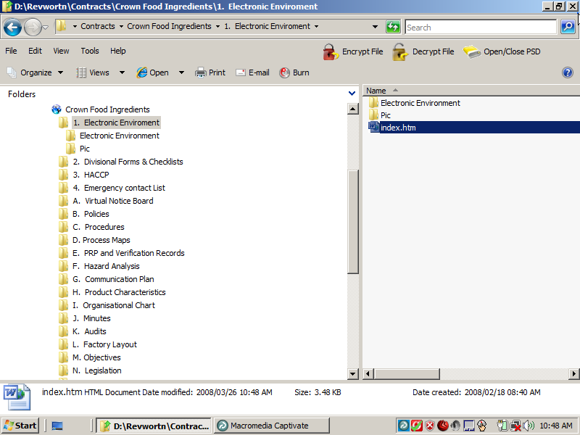
Slide 48
Note:
Notes:

